
Qwwdq

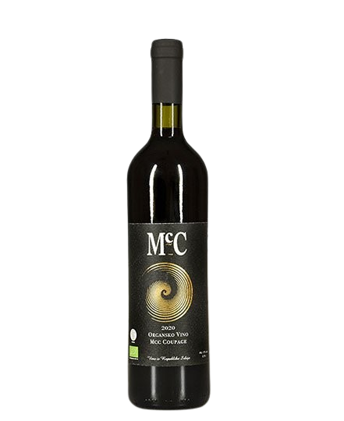
Coupage
- Dry red wine -

About the wine

Grape variety:
- Merlot, Malbec
- Cabernet Franc
- Cabernet Sauvignon
Origin: Erdevik, Fruška Gora
Serving temperature:14-16 ºC

We use the Bordeaux technique of co-fermenting grape clusters. At the same time, we ferment Merlot and Malbec together so they can mature in harmony. We also ferment Cabernet Franc and Cabernet Sauvignon simultaneously, even though they do not ripen at the same time. The idea is for the Cabernet Franc to be slightly overripe, while the Cabernet Sauvignon remains fresher and greener.
So we combine these two blends to create the final cuvée. Primary fermentation takes place in stainless steel tanks. Near the end of fermentation, the wine is transferred into oak barrels, using a Spanish technique inspired by Ribera del Duero. This interaction with the barrel gives the wine a distinctive creamy texture. A controlled amount of oxygen penetrates the barrel, promoting maturation and aging.
After fermentation is complete, all the wine is removed, the barrels are cleaned with ozone, and then refilled. The wine is then aged for at least 18 months in barrel, followed by a minimum of 10 months in bottle.
We produce an average of 3,000–4,000 bottles of the cuvée per year.
Malbec is a grape variety first planted in Serbia by Don McCulloch. Originating from the Médoc region, it is also successfully cultivated on Fruška Gora thanks to the favorable climate and abundant sunshine.
According to foreign authors and wine researchers, this wine “has the taste of a wine with full integrity,” as noted by Julia Harding MW.
Monty Waldin describes it as a “beautiful example of how a red wine can be complex and developed without being heavy, without excessive aging in oak barrels or over-extraction from the grapes.”
The quality of McCulloch wines is also highlighted by Duncan McFarlane, who states that Don McCulloch and Seka Nikolić are visionaries in re-establishing and developing vineyards in these ancient regions. Indevin Group is the largest wine producer in New Zealand.

Awards
For the 2011 vintage, we won a bronze medal at the Decanter World Wine Awards and a silver medal at Vino.rs.
For the 2012 vintage, we received a gold medal at Vino.rs in 2014. The 2012 vintage also won a silver medal in Croatia at the Gastro Fest in 2015.
The 2017 cuvée won a bronze medal in the category “International Wine Varieties” at the Saint Trifun Celebration in Belgrade, held on 13 February 2020. The event was organized by the Association of Winegrowers and Winemakers of Serbia.
2021 – The 2017 vintage won a gold medal at the Rivica Wine & Food Festival.
2022 – The 2018 cuvée won a silver medal at the Wine Vision by Open Balkan. In the same year, the 2018 cuvée was also included in the “Top 50 Wines of Fruška Gora”.
2023 – The 2018 cuvée won a gold medal at the Wine Vision by Open Balkan.

